TV show report - Reproducible Research assignment - revisited

Kamil Golis

5/11/23

#### Ad. 1

*Suits* is an American television drama series created by *Aaron Korsh*, which premiered on June 23, 2011 on the *USA Network*. It revolves around *Mike Ross (Patrick J. Adams)*, who begins working as a law associate for *Harvey Specter (Gabriel Macht)*, despite never attending law school. The show focuses on Harvey and Mike managing to close cases, while maintaining Mike’s secret.

The series was renewed for an eighth season on January 30, 2018. In January 2019, the series was renewed for a ninth and final season which premiered on July 17, 2019. During the course of the series, 134 episodes of *Suits* aired over nine seasons, between June 23, 2011, and September 25, 2019.

#### Ad. 2



## Ad. 3

library(readxl)  
library(psych)  
library(dplyr)  
setwd('C:\\RR_kg\\repositories\\RRcourse2023\\Quarto and MD 1')  
  
data_suits <- read_xlsx('data_suits.xlsx') %>%  
 mutate(viewers_millions = as.numeric(viewers_millions))  
  
t(describe(data_suits$viewers_millions))

X1  
vars 1.00000000  
n 134.00000000  
mean 2.17962687  
sd 1.06653850  
median 1.87000000  
trimmed 2.09055556  
mad 1.09712400  
min 0.69000000  
max 4.64000000  
range 3.95000000  
skew 0.61537847  
kurtosis -0.73620517  
se 0.09213489

## Ad. 4

#### View by Date

library(ggplot2)  
data_suits %>%  
 ggplot(aes(x=air_date, y=viewers_millions)) +  
 geom_line() +  
 ggtitle('Viewership over time (millions) by date')

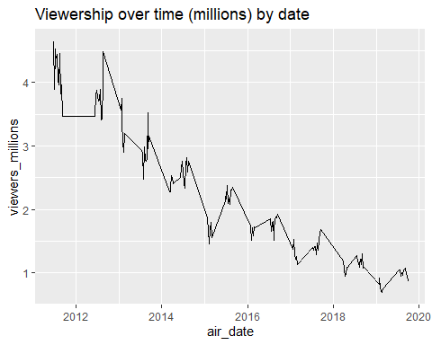

#### View by Episode number

data_suits %>%  
 ggplot(aes(x=no_overall, y=viewers_millions)) +  
 geom_line() +  
 ggtitle('Viewership over time (millions) by episode number')

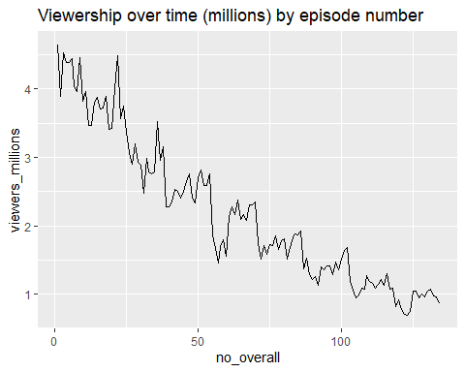

## Ad. 5

data_suits$viewers_delta <- c(0, diff(data_suits$viewers_millions))  
  
data_suits[-1,] %>%  
 ggplot(aes(x=no_overall, y=viewers_delta)) +  
 geom_line() +  
 ggtitle('Viewership delta - episode-to-episode')

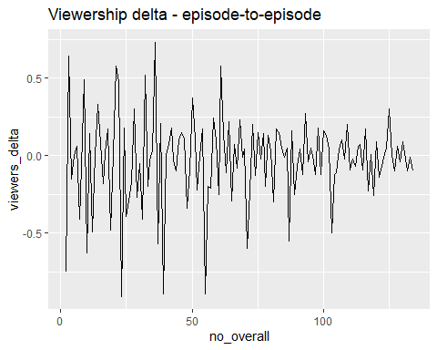

## Ad. 6

delta_s1_s9 <- abs(data_suits$viewers_millions[125] - data_suits$viewers_millions[1])  
delta_s3_s5 <- abs(data_suits$viewers_millions[61] - data_suits$viewers_millions[29])

The viewership decreased by 0.8 millions between seasons 3 and 9, which seems not that dramatic - yet when we look at the difference between seasons 1 and 9 - it is huge - 3.6. In general, As the seasons go on, we can observe a negative trend (as presented in plot Ad. 4)

#### Ad. 7

Added parameters:

* hide source code
* hide messages
* hide warnings

#### Ad. 7.1

Changed the strategy:

* instead of echo=false I did a folding of code - u can see the code if u want
* put the hide warnings as they are irritating in all relevant places
* added blank lines between sections

#### Ad. 8

Render done!